Dragons and Dungeons in the Dark

A Companion App for the World’s Most Popular RPG Game

Project Proposal by the 40KHD Group

Created: 10/13/19

Revision A: 10/25/19

Revision B(Final): 12/11/19

Created by:

Douglas Gromek, Geoffrey Kitchner

**Project Plan Purpose (DG)**

This project plan outlines the Dragons and Dungeons in the Dark application that was previously approved. It starts by giving a brief description of the app being created, and why there is currently demand for a product such as this. Understanding the user’s needs will allow us to expedite development by focusing on the key features and avoiding feature bloat and creep. Based on this information, the seven key functions of the application are then outlined. The main interactions between the application, its features, and outside systems are shown through a systems context diagram. A GANTT and PERT chart were then created and will act as a schedule that outlines the major steps needed to complete the project. The project staff and resources that are required to adhere to these schedules is then presented.

**Application Overview (DG)**

The tabletop RPG (“Role Playing Game”), Dungeons and Dragons, is currently one of the most popular in the country, with over 19 million players and counting. Our application “Dragons and Dungeons in the Dark”, will act as a companion for these players, providing them a comprehensive tool that will enhance their playtime experience. Although current applications already exist that mimic what we intend to create, they all have major flaws in their user interfaces, are cumbersome to use, or are missing key features. In improving upon these aspects, we will be able to build and maintain a large user base for our application.

**Problem Description (DG)**

A user wishing to start up a game of Dungeons and Dragons might find that they need to piecemeal together an assortment of tools that allow them to play the game. Physical dice of varying sizes will need to be found, character sheets will need to be downloaded from the internet and then printed out. A rules book will be carried around in either a bulky book form or electronically on a separate laptop, and notebooks will be needed to keep track of the player’s experiences throughout the game. This system is both outdated and time consuming. An “All-In-One” application can be created to simplify game prep, and keep the user playing long into the night. After polling Dungeons and Dragons players, we found that the main reason provided for not playing a game was the time needed get everything set up. In today’s fast paced world, the simplest and quickest option is usually the one chosen. The more time our users spend playing, the more time that will be spent using our application.

A lack of immersion was the second major complaint RPG players provided both as to why they did not start playing, and why a game was abandoned mid adventure. At its heart, Dungeons and Dragons is a shared adventure where the majority of the events happening throughout the game are expressed verbally. There are no fancy sets or virtual worlds that allow the player to better connect and believe in the adventure they are having. Because of this, even the smallest distraction can rip the player out of the game and back into the real world. Our “All-In-One” approach for this companion app will minimize these distractions. By having a built-in rules book, gameplay will not have to stop while the player searches through a large book. Instead, a simple search function will easily provide the player with the information they need. Our built-in dice roller and calculator will allow the player to focus more on what the dice rolls represent, the characters actions, and relegate the number crunching to behind the scenes. Further immersion builds the player’s passion, which in turn will increase their motivation to continue using our application.

**Business Benefits (DG)**

The gaming industry is one that lives and dies on public awareness. Entire games and applications can fail, not because of a flawed design or lack of need for the product, but because users tend to overlook or pass over things that do not have any public clout. As an emerging company within this industry, 40KHD needs to make a statement that increases the public’s knowledge and support of our company. Doing this will allow us to make larger applications in the future while minimizing our financial risk. Through the creation and continued support of “Dragons and Dungeons in the Dark”, we will be able to create a large and stable player base that we can count on as users for our future projects. Being such a widely played game, Dungeons and Dragons is a safe choice for the creation of an application aimed at increasing user support of our company. Although the business benefits from this project will be mostly non-monetary, continued support of the application post launch will be paid for by the application itself, so as to not create additional company overhead. In game purchases of features such as themes and save lots, as well as a premium version targeted towards heavy players will be available to offset the costs of continued support for the game.

**User Benefits (DG)**

Our application will provide a more user-friendly experience playing Dungeons and Dragons. Instead of worrying that they have all the required materials, a player will instead have to simply open the application and get started. This means games can get started in shorter amounts of time in order to fit them in around player’s busy lives. Once the game has started, the player will be as immersed as possible, and our game application will be the only outside source that they need. If the game does need to be paused for any reason, the player can be confident that it can be returned to at any point in the future, without having to worry about keeping track of player sheets or other information that might get lost if stored in a physical form.

**System Capabilities (DG)**

Seven features make up the core of our application. Working in unison, they provide the player with an optimal game experience.

*Character Sheet*

The character sheet serves as the main method of interaction between the player and the application. It acts as a hub from which all other functions branch off from. Its main screen will display the user-character’s basic information, attributes, and key items. At the top of the character sheet will be multiple tabs that allow the user to easily view additional character information (spells, skills, equipment etc.), or use other functions. The comment sheet, rule book, and dice roller functions will all be accessed through these tabs. There will be an additional drop-down menu that provides access to the save slots, character sharing, and settings features. The character sheet page will be a mix of information that must be manually entered by the user, and information that will be automatically updated as the game progresses based on dice roll results.

*Dice Roller*

The user will be able to select this feature at any time and choose to roll a set of dice of their choosing. The application will be programed to allow the user to choose between dice ranging in sides from 2 – 100. In addition to the die size, the user will be allowed to choose how many of each dice they would like to roll. Post roll, relevant information such as the roll total will be calculated and provided to the player.

*Comment Sheet*

This feature will provide the user with an editable text field that they can use to record in-game actions and events beyond what our application handles. Attempting to hold all in-game information within different tabs would quickly lead to a slow, bloated application. Providing an area where the user can choose which information they deem worthy of saving will create a more tailored game experience.

*Interactive Rule Book*

The rule book will be a text document of the official Dungeons and Dragons rules. There will be a basic search feature that allows the user to enter a word or phrase and quickly view instances of it throughout the book. Because game edition preference varies, the user will be able to select a rulebook edition that pertains to the version of their choosing.

*Character Sharing*

Two options will be provided that allow the user to share their character and game information. A free option will automatically create an image displaying information found on the character sheet. The user will then be able to download this to their device, or upload it and share it with friends on social media. A second, more comprehensive option will be provided to users of the premium version of the application. This will create a PDF file which combines all character information, the comment sheet, user settings, and roll results. This option effectively creates a play-by-play of the entire game.

*Save Slots*

The user will automatically be provided with one save slot that allows them to pause the game, saving all information related to that character, and then resume the game at any point in the future. This information will be saved in a file on the device itself, avoiding issues when trying to use the application without internet access. Heavy users who might want to have more than one game occurring at the same time will be able to purchase additional save slots. If the user opts for the premium version of the application, their save data will be saved on both the phone as well as on cloud storage. This allows for recovery of the information if the user must use a new device.

*Customizable Settings*

The settings customize the application to meet the user’s needs. Planned options include:

* Sound effects such as dice rolling and sword clashes during combat
* A dark mode to change the screen background to black with white font
* Premium themes that match the character’s race and class
* Rule book edition selection

**Avoiding Project Creep (DG)**

In order to minimize development time and costs, some features are not being included in the project that could be implemented post launch. Detailing these items now will ensure that they are not proposed or attempted mid project. We feel that the major functions and options we are providing in the initial edition of the application will be plenty to ensure user satisfaction. The features that will not be considered for this development cycle include:

* Multiple languages (Asia represents a large portion of the RPG fan base)
* An automatic character creator that would allow the user to play a character with randomly generated stats
* A visual model of the player character that shows basic visual information such as race, class, and equipment
* Visual effects such as dice rolling
* A customizable base character sheet allowing the user to decide what information should be on the main page, and what should be relegated to tabs.

**System Context Diagram (DG)**

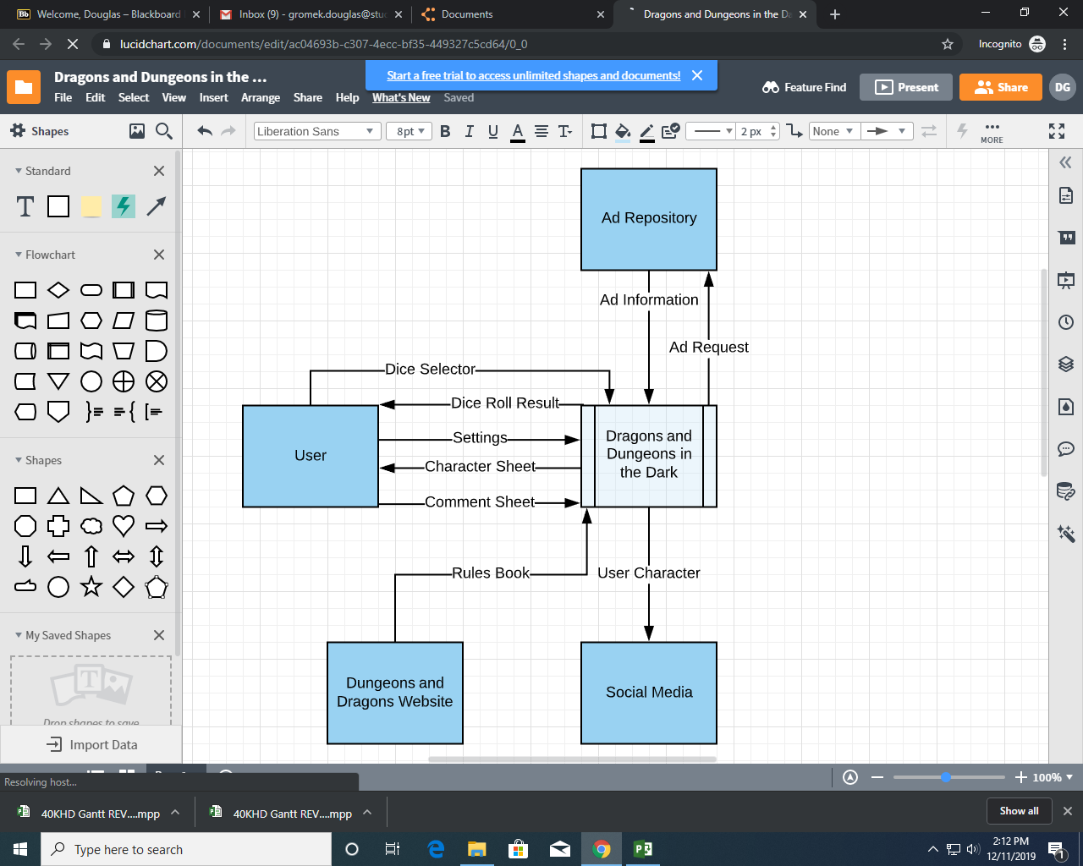

**Gantt Chart (GK)**

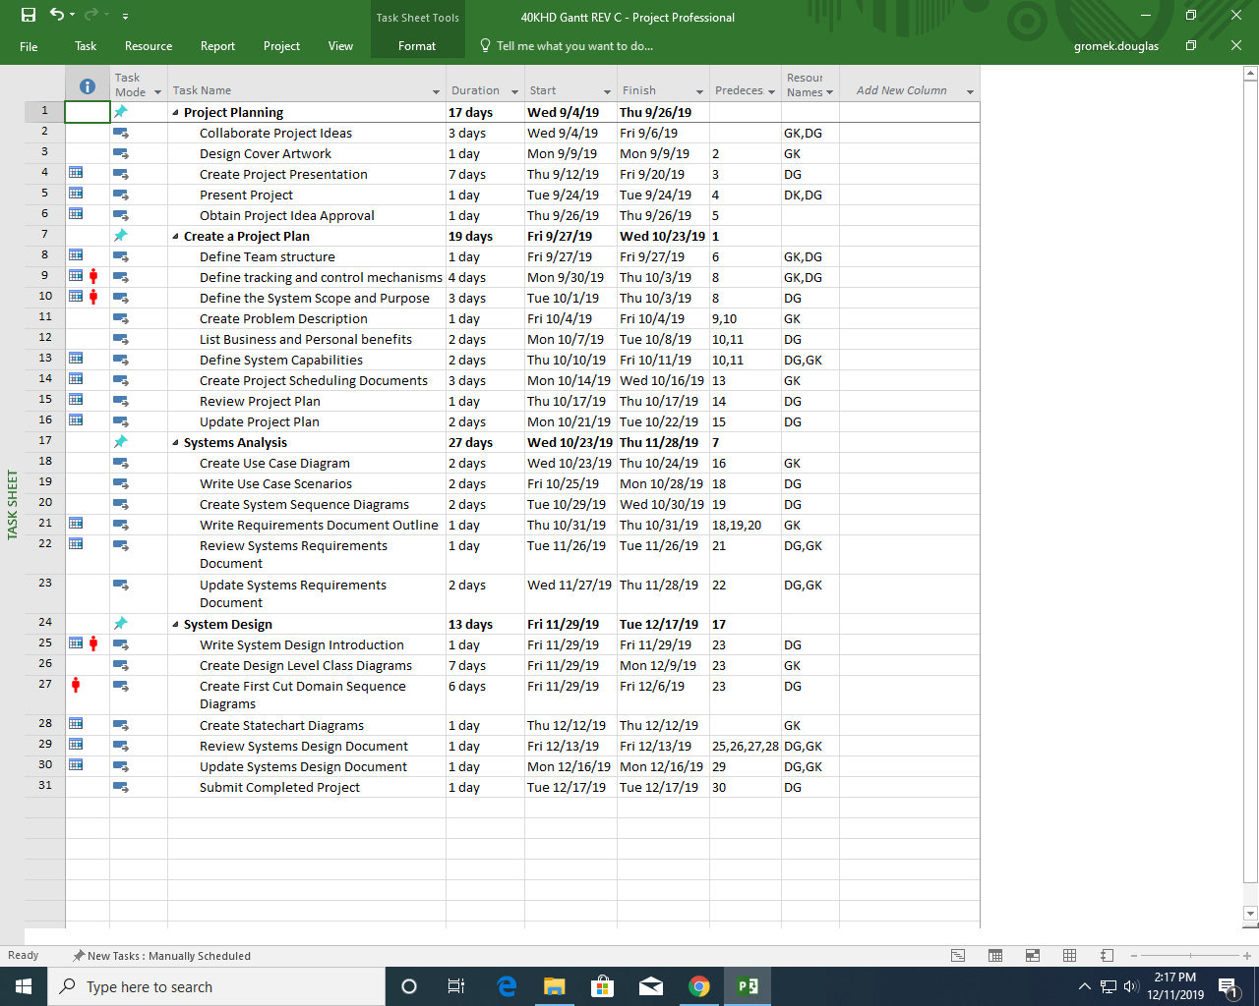

See Attached Diagram

**Pert Chart (GK)**

See attached diagram.

**Staff Organization (DG)**

Staff Resource Table

|  |  |  |
| --- | --- | --- |
| **Team Title** | **Name** | **Resource Size** |
| Project Manager | Douglas Gromek | 1 |
| Software Manager | Geoffrey Kitchner | 1 |

Resource Overview

|  |  |
| --- | --- |
| **Resource** | **Use** |
| Microsoft Project | Maintain up to date Gantt and Pert charts |
| Microsoft Visio | System Context Diagram and graphical chart creation |
| Blackboard | File Sharing and email |
| Discord | Discussion board for keeping group members updated |

*Project Manager/Team Leader (1)*

Responsible for control of the project as a whole. Directs the rest of the team in order to meet the deadlines and goals set out within this project plan. Acts as the main point of contact between the project team and the project owner (teacher), conveying progress and issues as they arise. Allocates the provided resources and assigns work in a manner to best expedite the project. They will hold two, 15-minute, project-wide meetings each Friday in order to keep team members in sync.

*Software Manager (1)*

This team member will have the highest knowledge of the subject of the application being developed (Dungeons and Dragons). Because of this, they will act as the “Idea” head of the project, making decisions about the application functions and the user interface. They will work closely with the project manager and help them to understand the functions of the application and how they can be implemented to provide the best user experience. Meets with the team leader twice a week to ensure progress is continuing smoothly and that

**Tracking and control mechanisms (DG)**

The Gantt chart outlined in this project plan will serve as the master schedule throughout development. Any proposed changes to it must approved by the project manager, who will be the only person authorized to edit it. The free chat application, discord, will serve as the main method for communication between team members. Blackboard will act as a free project dashboard software to send emails and share project files between the team members. These internal project documents will include things such as this project plan, completed sections of code, documents detailing specific issues and comments associated with them, UML diagrams, and example images such as character sheets. All team members will be able to edit these documents however, all changes to the project schedule must be approved by the project manager. All other changes should either be agreed upon by all team members during a meeting, or announced through the discord server.